FIPA DPDF Working Group
Internal document
Author: M. Cossentino
Reviewers: A. Gomez, A. Molesini, A. Omicini.
Date: 9/30/2009 05:02:00 PM

Process Documentation Template

Index
Introduction Section 2
Global Process Overview (Lifecycle) 2
Metamodel 3
Definition of MAS metamodel elements 3
Phases of the Process Section 4
Phase 1 4
Process Roles 5
Role 1 5
Role 2 5
Activity Details 6
Activity 1 6
Activity 2 6
Work Products 6
WP 1 7
WP 2 7
Phase 2 7
Work Product Dependencies Section 7

Document Outline
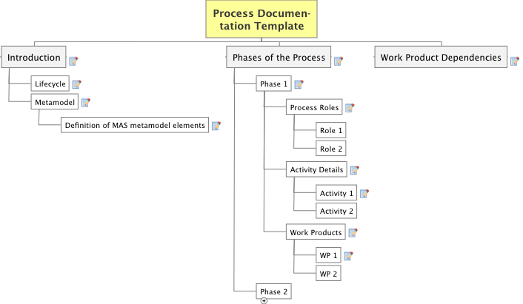

Introduction Section

- GOAL
- This section aims at introducing the philosophy of the process. Its basic ideas, the scope, and the limits.

- STRUCTURE
- Discuss:
- concepts at the basis of the process
- A ‘classic’ figure of the process
- quick description of the process (using original process terminology if useful)
- scope of the process (kind of MAS, size, architecture, type of problems, Implementation platforms supported, ...)
- limits of the process
- reference materials and documents

Global Process Overview (Lifecycle)

GOAL
the aim of this section is to organize the process phases according to the selected lifecycle (or process model) in order to provide a bird-eye view of the whole process at the highest level of detail.

STRUCTURE
- a picture depicting the process lifecycle at the phase level and clearly showing the adopted process model (waterfall, iterative, ...)
- a description of the process phases

Metamodel

GOAL
the aim of this section is to provide a complete description of the MAS metamodel adopted in the process with their definitions.

STRUCTURE
An initial introduction to the basic concepts used in the metamodel.
The level of granularity adopted in the metamodel should be reported as well.

Include a picture of the MAS metamodel adopted in the process

Definition of MAS metamodel elements are provided in the following sub-section

GUIDELINES
Metamodeling abstraction levels are subject to the designer point of view, aim and the process philosophy.
Sometimes metamodel opnly address the main elements of an approach with the goal of showing the concepts at the basis of&nbsp; the process and their relationships.
Other times, a complete metamodel is used as a modeling notation language and this usually brings to huge (but high-fidelity) metamodels.
First kind of metamodels are sometimes addressed as 'ontological' (PUT HERE a REF) while some others as 'linguistic'.
It is up to the author of the process documentation to establish the levell of granularity s/he will adopt in this document. A reccommendation is only raised in order to ensure coherence in the different parts of the document and specifically with the modeling notation described in the Work Products sub-sections of each phase section.

Definition of MAS metamodel elements

A table with the definition of the MAS metamodel elements composed of the following columns:
1) Concept: name of the MAS metamodel element
2) Definition: a complete definition of the element
3) Referred Concepts: A list of concepts used in the definition of this element and defined elsewhere in the table
4) (optional) Domain: If the metamodel is divided into domains (or layers), the name of the domain the specific concept belongs to.

Phases of the Process Section

GOAL
This part of the document is composed of one section per phase. The aim is to detail the whole process by adopting a tree decomposition of it on the basis of its workflow composing elements studied at different levels of granularity (phase-activity-task).

STRUCTURE
One section like this for each phase of the process.

Phase 1

GOAL
Each phase is now studied from a pretty process-oriented point of view. Workflow, work products and process roles are the center of the discussion.

STRUCTURE
Introduce the phase workflow by using a SPEM activity diagram reporting activities composing the phase.
Quickly describe work products and roles.

Introduce a SPEM diagram reporting the structural decomposition of the activity in terms of the involved elements: tasks, roles and work products

This initial introduction is followed by three sub-sections:

1) Process Roles:
2) Activity Details
3) Work Products

(details in corresponding subsections)

GUIDELINES
The process is supposed to be mainly composed of three different levels of granularities with regards to the work to be done: phase, activity, task.
Phase level work is supposed to deliver a composite work product (or a set of WPs) whose size is like that of a ‘System Analysis document’ or ‘Detailed Design document’
Activitis are supposed to deliver a major work product like a diagram or the code of a software component or the textual list of requirements
Tasks are supposed to concur to the development of a major work product.
Tasks are regarded as atomic unit. This assumption as to be adopted according to the goal of providing a complete/clear description of the process. In many processes tasks could be furtherly decomposed but this would bring no significative advantage to process documentation.

Process Roles

GOAL
The aim of this section is to list the roles involved in the work composing this phase and clarifying their level of involvement in the job to be done.

STRUCTURE
Describe the responsibilities of each process role in the activities composing this phase. Roles can be responsible for activities or assist in them. The different level of responsibility (responsible/assist) should be clearly stated.

GUIDELINE
Adopting a common taxonomy of process roles could encourage process sharing and the reuse of their portions (fragments). A list of roles has been proposed in the paper by V. Seidita et al presented at AOSE'08

Role 1

Role 2

Activity Details

GOAL
The aim of this section is to detail the work to be done inside each activity (decomposing it in further level of abstractions if needed)

STRUCTURE
One subsection for each activity
describing activities/tasks composing the selected activity by using a SPEM activity diagram including the involved roles (as swimlanes)

Activity 1

STRUCTURE
Detail tasks and sub-activities by using a table with the following columns:
- Activity (name of the actiity studied in this sub-section)
- Taks/Sub-Activity: Subactivity or task described in this row of the table
-Task/Subactivity Description: obvious...
- Roles involved: obvious...

Activity 2

Work Products

GOAL
The aim of this section is twofold. The first part aims at detailing the information content of each work product by representing which MAS model elements are reported in it (and which operations are performed on them). The second part focusses on the modeling notation adopted by the process in the specific work product.

STRUCTURE
Work products produced in this phase are described by using a workproduct structure document.
This diagram (and extension to SPEM specifications proposed in an AOSE 2008 paper by Seidita et al.) is a structural (class) diagram reporting the main work product delived by the phase at its center and then the composing (or other not related) diagrams around that.
The structure of each composing diagram is then expressed in terms of the MAS metamodel elements defined/related/refined/quoted in it.

A table is used to describe the scope of each work product.
The table has 3 columns:
1) Name: name of the workproduct
2) Description: a description of the content
3) Work Product Kind: classification of the work product according to the paper V. Seidita et al presented at AOSE 2008 (categories: free/strctured text, Behavioural, Structural, Composite)

WP 1

GOAL:
The aim of this subsection is allowing an easy adoption of the modeling approach proposed by the original process to the reader of this document or conversely, providing the creator of a new modeling notation with a clear idea of what is required in order to properly support the modeling demands of this document.

STRUCTURE:
A subsection is now reported for each different work product in order to describe the notation and the template of the document as it is normally suggested by the original process.

The structure of this subsection includes:
1) a description of the document with a specific mention of the notation adopted.
2) Examples of the document parts. These examples also include tables, diagrams, outlines of specific portions of text used for describing the design.

WP 2

Phase 2
See Phase 1

Work Product Dependencies Section

GOAL:
The goal of this document is providing a representation of the dependencies among the workproducts and therefore (indirectly) among the activities that produces them.
This can prove very important to project manager who have to reschedule project activities according to new need occuring at design time.

STRUCTURE
This is a classic diagram (also specified by SPEM). All the workproducts produced by the process are reported in the diagram and a (dashed) line is used to relate two of them if one is an input document to the other. Direction if from the input document to the consumer one.

It is to be noted that according to the importance that is payed to the MAS metamodel in the AOSE field, the real input of each portion of process is a subset of model elements (instances of the MAS metamodel) that constitute the portion of design reported in the input documents.

